**Inquisitor/Inferno mini-overview on builds / rotations:**

-hastily thrown up by Shurali (Solali)

-updated for 3a

**General tips/notes:**

Your synergy effect is applied on hitting with your fire attacks for 10 seconds, easily refreshed. It’s not as simple as Fnen just buffing the party, but it’s still pretty straightforward.

Purifying Flame is a hold that activates pretty instantly and works as long as the target is on fire (which they should be pretty much anytime you hit them), so timed properly can be used for those rare gimmicks that can be held. It also cancels anything you need if you need to squeeze in that damage asap. Essence also holds on targets on fire for the same thing, but you have to aim it.

Vortex is a good grouping skill, so even with no damage it's good to use to grab the mobs for trash mob clears with P. Wallop.

Inferno also has a unique backdash air attack and you'll be auto'ing a decent amount inbetween, so do so when you can. It has a cd though, so you can't do it back to back to back.

God's Wrath is faster from the air, so in 20 second rotations you need to backdash quickly and do it from the air to be able to fit properly (and doing it in general is better since bosses move, etc). Feel free to just jump and immediately god's wrath instead if it's awkward, you lose like one basic attack (but you also lose cool factor so). For sirocco I've found there's enough time to wait for the whole animation, so you don’t need this for her 25s groggy.

**Weapons:**

Both are actually pretty comparable. Vulcanus is generally better, but I’ve seen builds where Weight ends up being better. Vulcanus gives a very sweet +3 to 1a, and makes Decollation a huge room clearing cube skill. Weight of Faith actually gives really good modifiers and also adds 20% Attack Speed half the time, which is noticeable during rotations a lot of the times. The other half, 20% Movement Speed, also helps in triggering War God’s break points. Use the calc for optimizations.

With the 3a update, a lot of people tend to lean towards Weight now, due to the fact that 2a does a decent amount more than 1a and people overwrite 1a with their 3a. Test separately - if Vulcanus still gives more output than Weight, overwrite 2a with your 3a instead.

**Skill Building**

Inferno's one of those classes where the talismans help a shit ton on a couple of her otherwise okay skills (Decollation is always good though).

The best talisman's Summary Justice, then Noble Rage/Decollation, then Inferno Vortex (imo). Purifying Flame's the farming one, not so much for anything else.

**Without Talismans:**

Throw points in every cube skill first, except Vortex, Noble Rage, and Summary Justice. Then max out the entire firebomb tree (Holy Fire, essence, etc). Put a point into Cut-In Dash for mobility, and max Punishing Wallop. Then throw leftover points into whichever skill you like more between the three you didn’t from above. I’d usually do Vortex assuming zero talismans due to okay mob clearing.

With the 3a update, move points away from Purifying Fire and Essence if needed to max the new 95 skill (assuming you’re spending points into your two Tali skills).

**With Talismans:**

Similar to above, you throw points in every cube skill + the talisman skills you chose + Punishing Wallop, and 1 point in Cut-In Dash.

The Summary Justice talisman makes it actually good for damage since it removes the long hold animation and just does the nice aoe, and its low cd, so once you get that you max that skill if you choose to use it. This does remove the hold on it, but you have plenty of other holds to choose from, and end-game content often either can’t be held, or actually punish you for holding so it’s usually just pure upside.

The Noble Rage talisman speeds up the animation immensely, making it much more usable for damage - this makes it worth maxing as well once you get and use the talisman.

The Decollation talisman doesn’t fix the skill or anything (since the skill’s great even without the talis), but it does add a guaranteed Holy Fire after it, so adjust rotation properly. You max this skill regardless of whether you’re using this talisman or not.

The Inferno Vortex talisman changes the skill from “spin the entire duration and waste probably some precious seconds unless its mob clearing” to “spin for 1 second or so and the tornado stays while you can do other moves”, thus making it much better for rotations and damage. I prefer the above 3 over this, but this is fine to use and max vortex as a skill instead.

The Purifying Flame talisman changes the move to not require a burning target (pretty pointless, they’re always on fire), and also do it in an aoe around you (so multiple people get hit by it). It’s good for farming, doesn’t add as much for boss fighting imo.

Example build below is with Summary Justice talisman and Noble Rage talisman (post-3a):

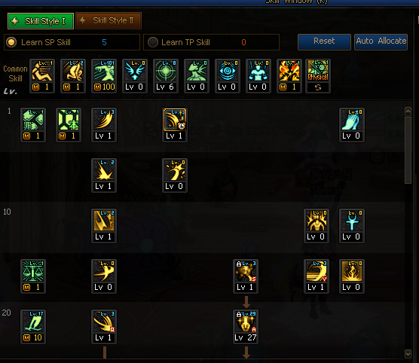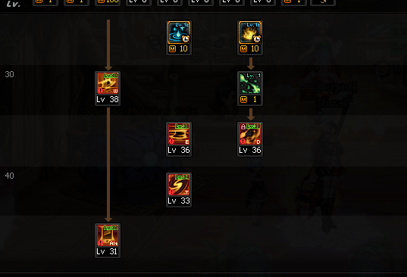

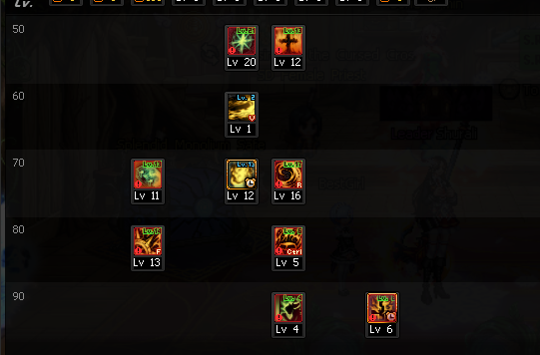

Noble rage/Summary Justice are maxed here as those are the talis I’m using but if you don't have these, or any other talis to max instead, i'd throw the points into perhaps castigating wallop/vortex/firebomb instead. Max crit of course always when needed.

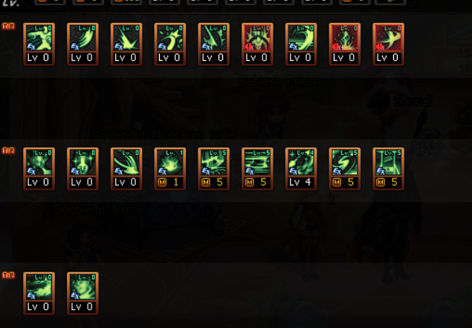

Example TP Build:

Summary and Noble Rage are maxed for similar reasons to skill build point usage.

**General Notes on Rotations:**

Essence/Holy Fire can cancel the post animation of most skills, so you can weave them in smoothly after most stuff. Your goal is to throw in them as many times as possible after cube skills when you can. Holding forward with essence is usually better imo, since it sprays it in a wider aoe.

Fit Firebombs inbetween cds whenever you see fit, but remove them if it screws up squeezing the cube skills.

Without any special talismans at all, the 20 second rotation should aim to begin with essence and punishing wallop, and you cancel into Holy Fire as much as possible. After the first essence/wallop/fire, you should do Christening Fire into Punishing Fire(Christening can only be canceled by Punishing Fire, Punishing Fire can cancel anything that's not an awakening), then Decollation into 1a while your cds cool down. 1A will also help out lowering CDs so you can fit more followup essence/wallop/holyfires. In 20 seconds with 0 talis you should be able to fit two Christening Fires because of the 1a CDR, but barely.

With talis: Summary Justice can be fit twice in 20 seconds, and becomes a much more important damage tool for rotations. Importantly it actually has a super long, annoying post animation delay so you almost always want to cancel it with Holy Fire/Essence.

If you’re using the Noble Rage talisman, it can be fit twice for 25s rotations, so begin with it for 25s rotations if you have the talis. It’ll just barely be in range, so make sure you squeeze in Punishing Wallop a little early for 25s rotations whenever off cd so it doesn’t clash with the cd on Rage. You can only fit one for 20s, so put it in whenever, preferably over a Castigating Wallop.

If you’re using Inferno Vortex talisman, with 1a it can also be fit twice for 25s rotations but you have to begin with it. Will be a little close. Same notes as Noble Rage for 20 second rotations.

If you’re using Decollation talisman, you get a Holy Fire reset immediately after using it, so that’s the one thing you have to take in mind. Otherwise, this is the simplest.

With the 3a update, it’ll be a little tighter fitting skills in. The 95 skill, Inverted Cross, can be slotted in the middle pretty freely due to low channel time, and the general advice I usually do for 3a’s are to fit them in the middle of some longer cds to not waste the channel time as much. We can’t all be Vagas.